Main Page: Section #1

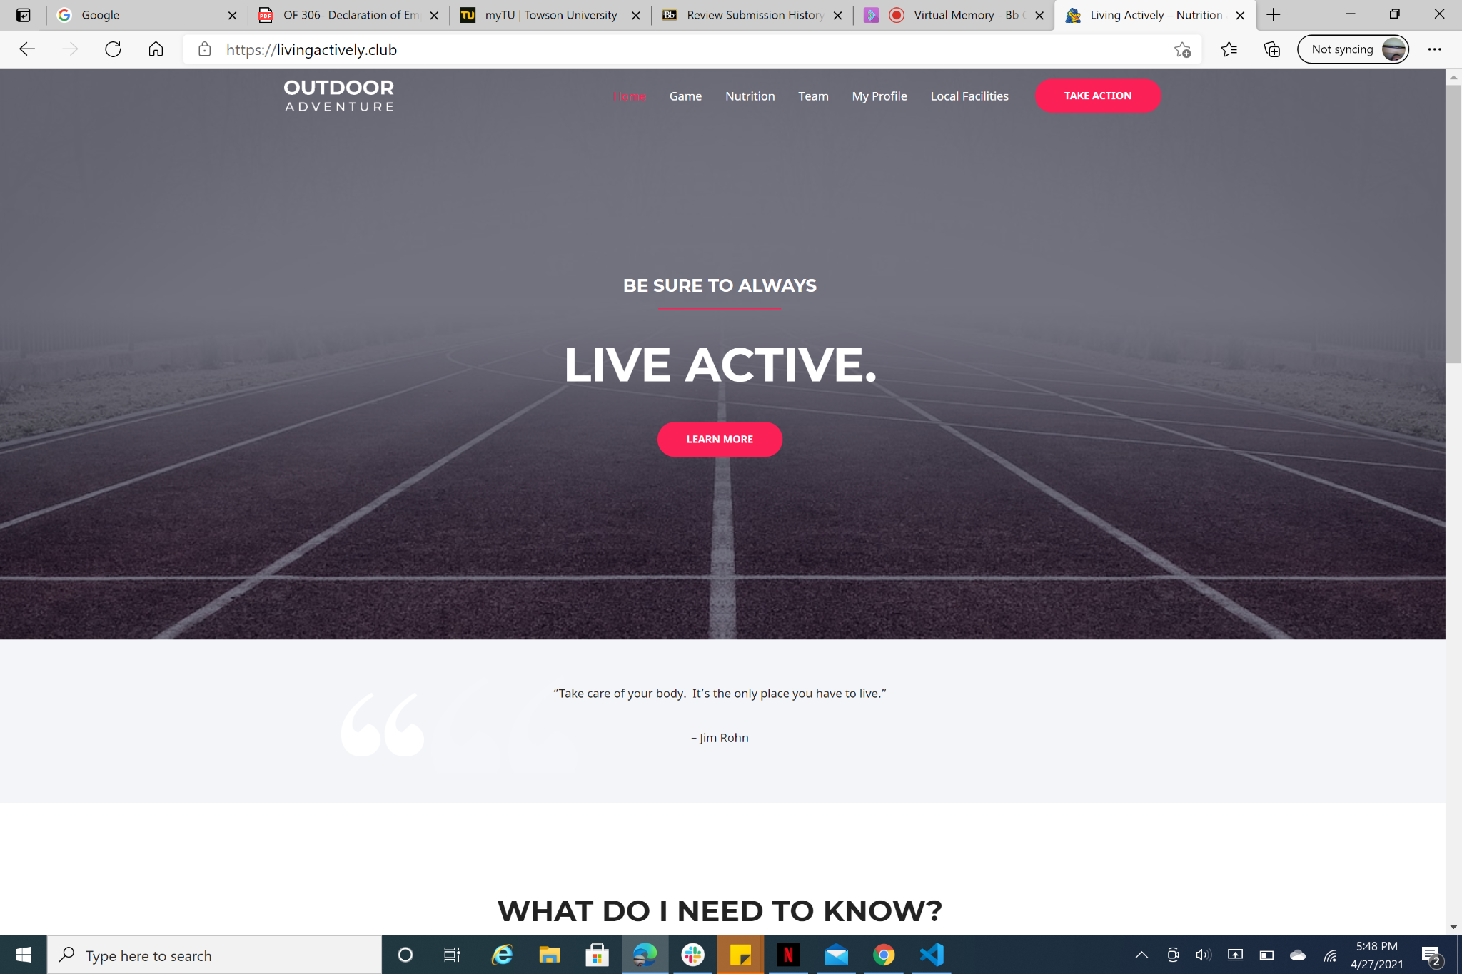

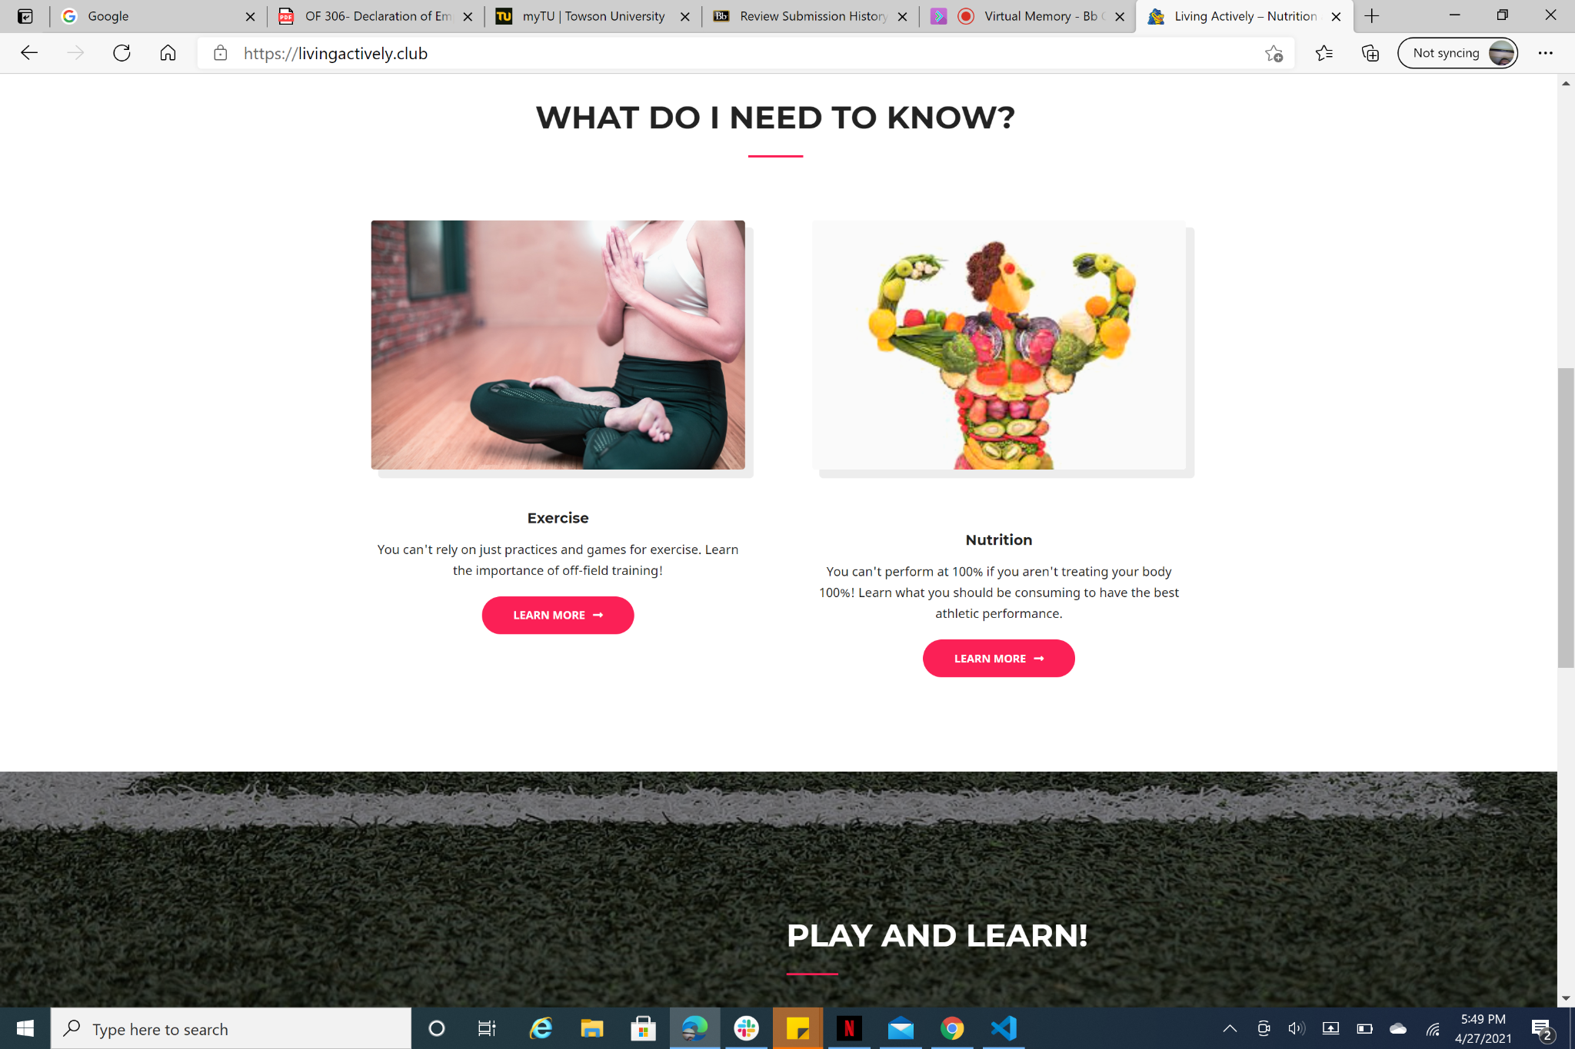

**Focus of the user(s)-First impression**

**Message**: The visitor(s) can identify what the website is about in less than 5 seconds or less

**Next step**: the visitor/users should see where to go next from the main page (click button(s)).

**Visual:** the main page has s central image, gallery, live chat, and a footer with links.

**Invoke the emotion**: does it make a good impression.

Nutrition: Section 2

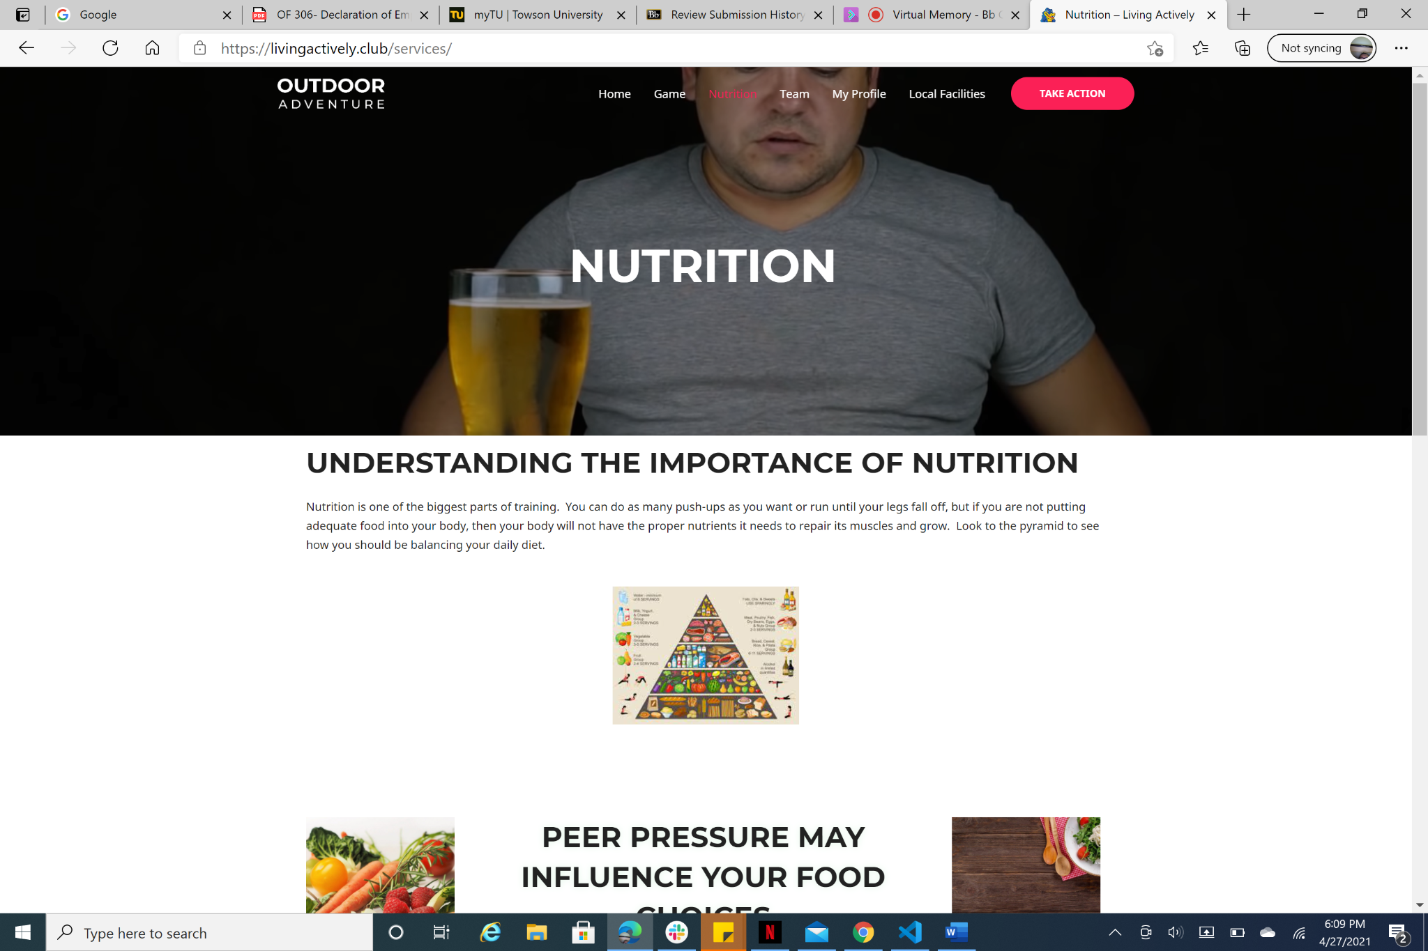

On this webpage, users get expert advice regarding nutrition.

User Profile Section: Section #3

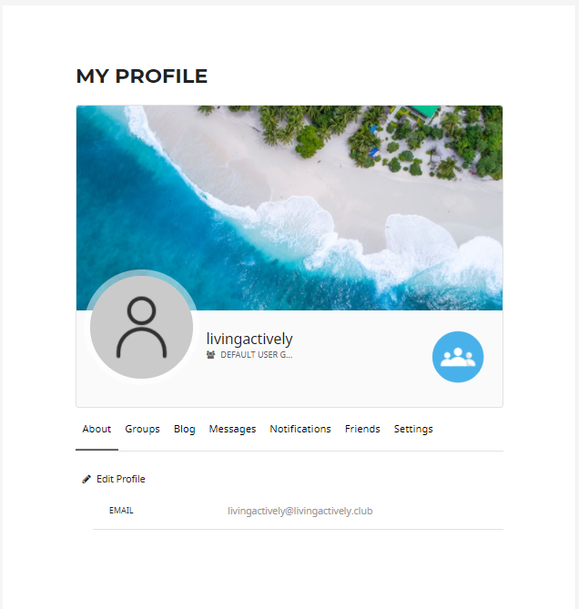

User Profile page allows users to:

* edit their profile,post contents and chat with other members.
* send a friend request to other members of the website
* create or join a group
* get a notification when other members post a content

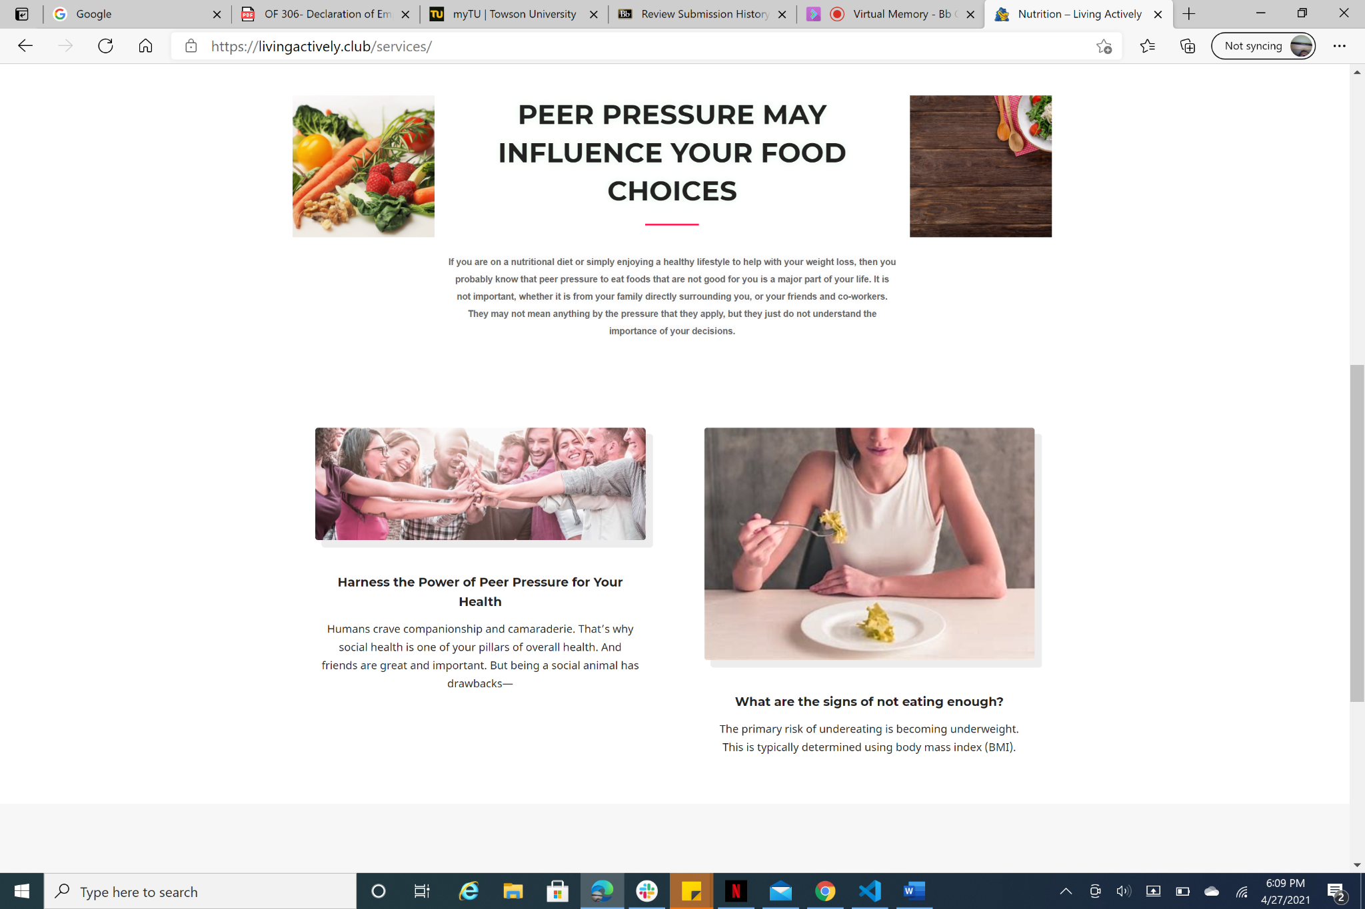

**Visuals:** The user is met with friendly and easy to read pictures that pertain to one's health.

**Page Focus:** This is meant to focus on health that will make the user think about their health and gain small and useful information about health.

**Takeaways:** The main takeaways from this page here is to have the visitors of this website see the importance of Nutrition and how it pertains to one's health.

Team: Section 4

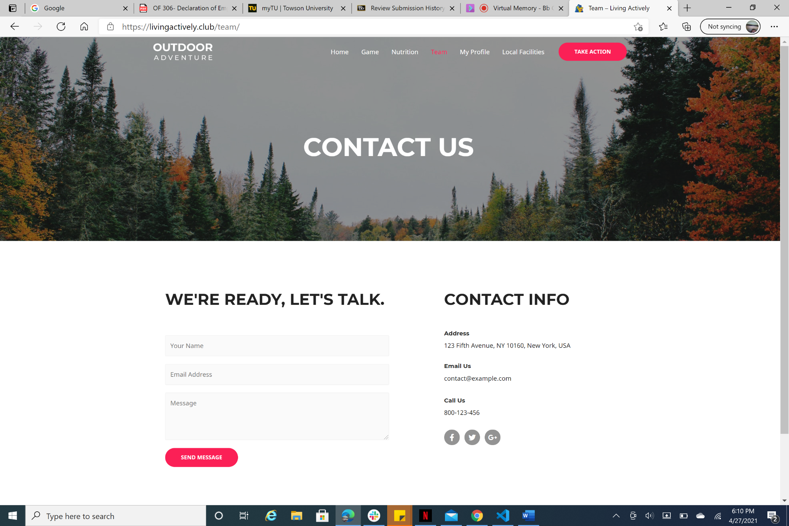

Users are able to send message in regard of website issues

Users has to fill out the required fields then click on send message

Register/Login : section #5

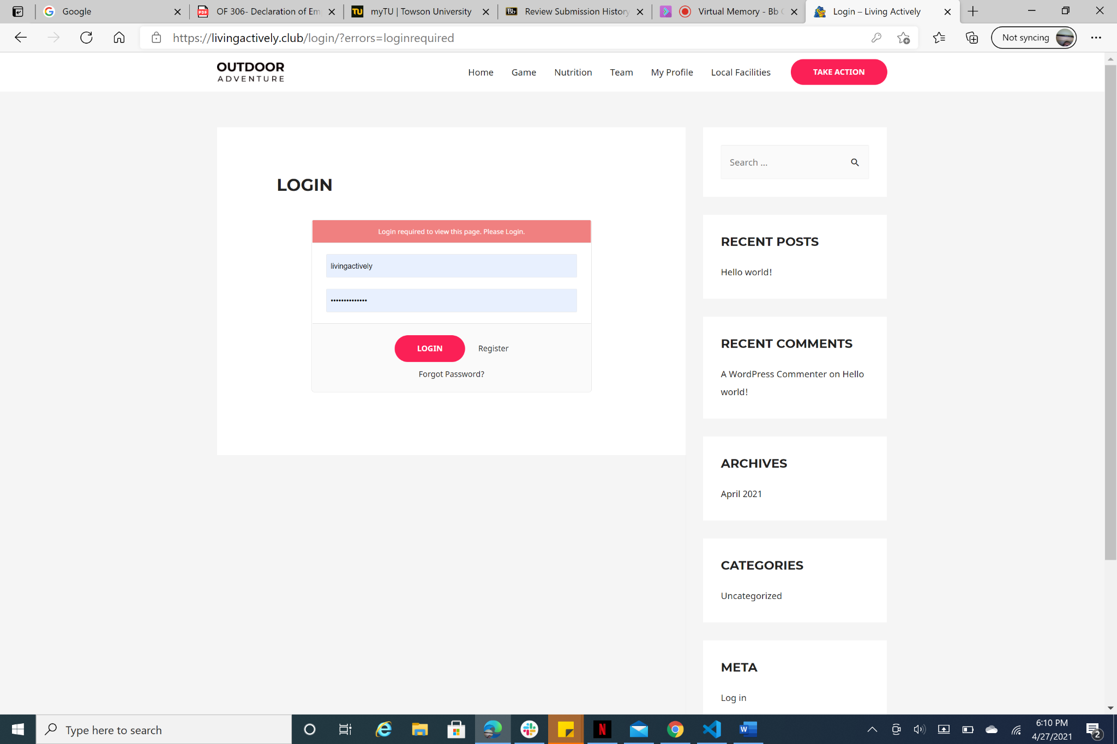

Users have the ability to log in or register if that is their first time on the website.

Local facilities: section #6

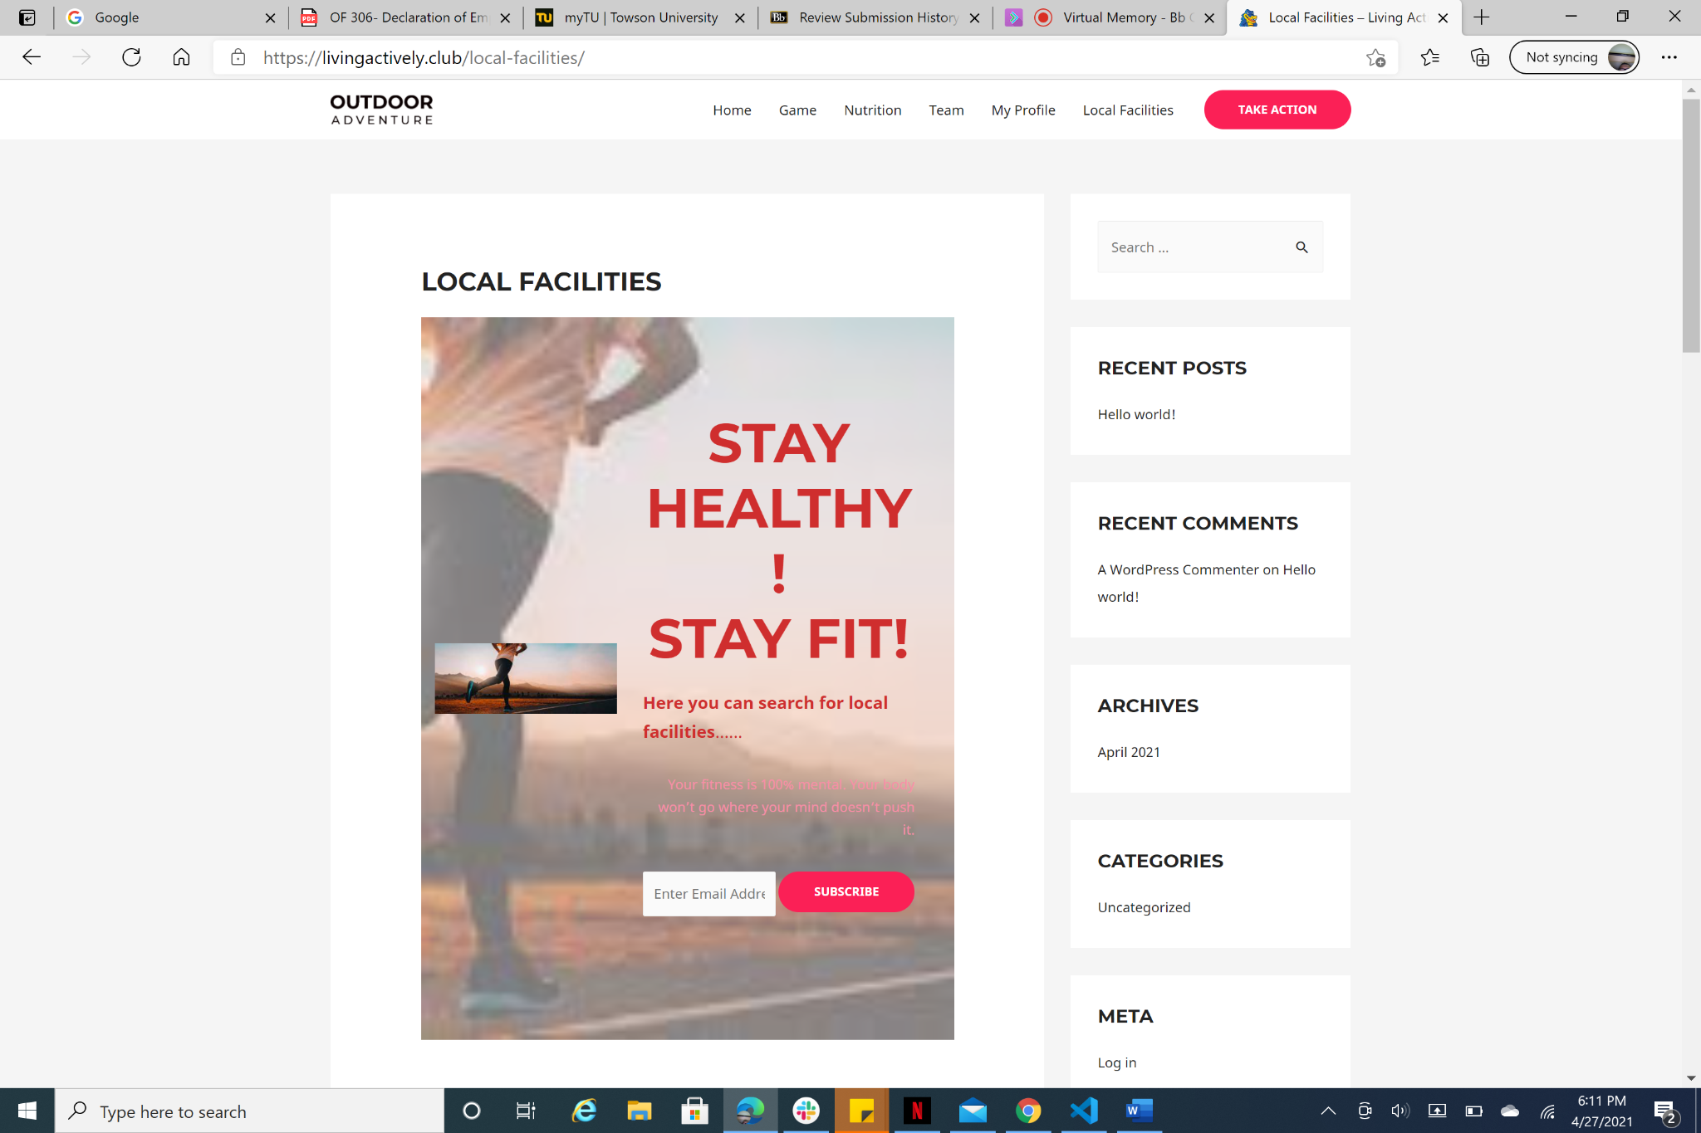

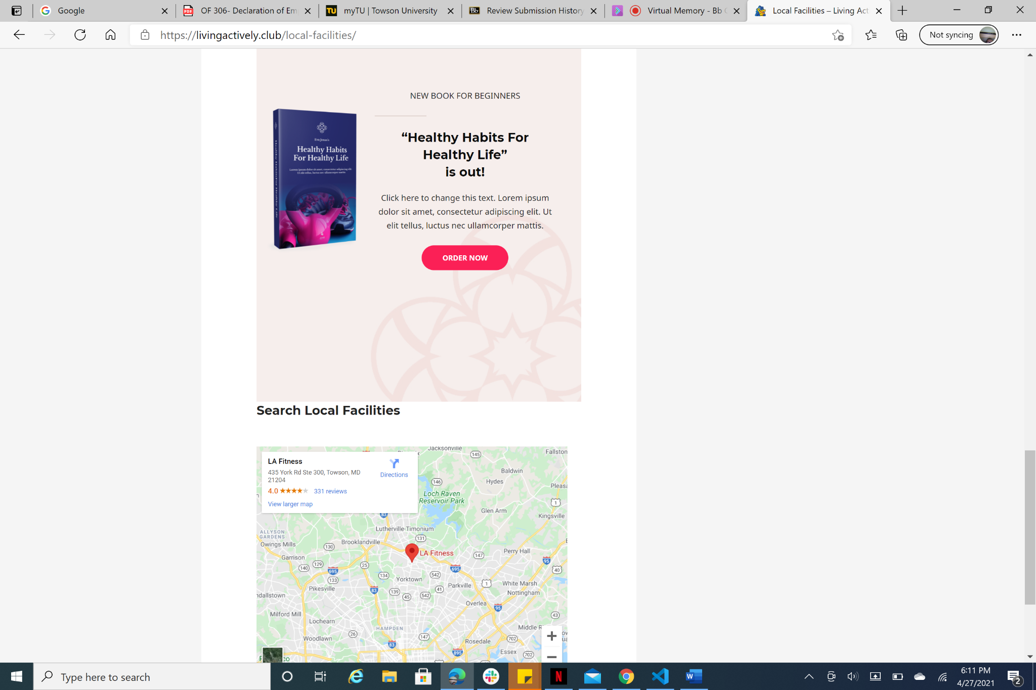

On this webpage users are brought to an area where they can subscribe to a book about nutritional health

This page is also used to bring the closest gym facility to the user using geolocation is prompted by the user's acceptance to do so.